TOWERS OF HANOI

Rules:

* 3 rods and n disks will be there.
* No disk should be placed up on smaller weighted disk.
* Only one disk should be moved at a time.

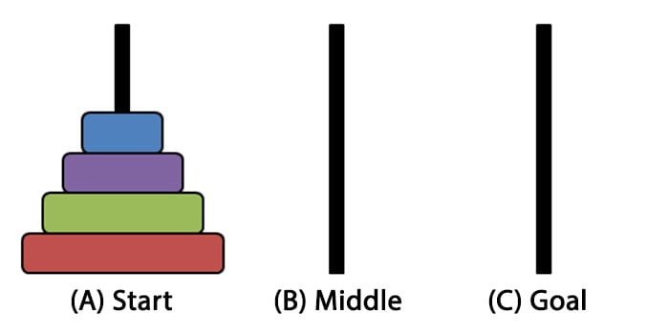

Moves Required:

Minimum moves required : (2^n-1)